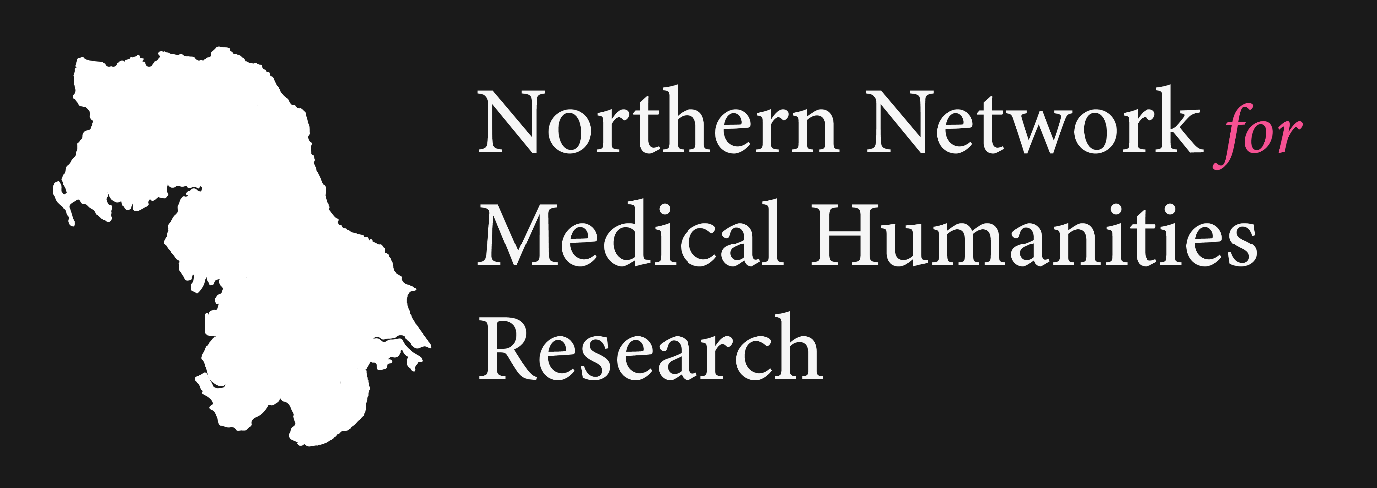

THE NORTHERN NETWORK FOR MEDICAL HUMANITIES RESEARCH (NNMHR)
NEW NETWORKS IN CRITICAL MEDICAL HUMANITIES FUNDING SCHEME

Round Two (Deadline 12th May 2023)

APPLICATION FORM

1. NETWORK NAME AND CONTACT INFORMATION
- Name of Proposed Network
- Please give the name, contact email address, institutional affiliation (if applicable), and a short biography (max. 100 words per person) for each network leader. All network leadership teams must include at least one early career or postgraduate researcher.
- Please confirm the name of the network member and institution that will be responsible for the administration of Network funding should this application be successful.
- Please confirm that you have attached a letter of support from the administering institution. The letter of support is to confirm that the institution is willing and able to bear the cost associated with the grant in the first instance; requests for reimbursement of costs will be made to Durham University (representing the NNMHR) on a quarterly basis, with evidence of spend in arrears. (See ‘Administration of the Award’ for further details.)

2. DETAILS OF PROPOSED NETWORK (1000 words max.)
Please use this section to tell us about your proposed network, using the following questions for guidance:
- What is the purpose of your network, and how it will make an innovative and original contribution to the field of critical medical humanities?
- What activities do you propose to undertake with this grant? Please indicate, wherever necessary, what practical structures will be put in place to support this programme.
- How will your network benefit its members?
- Please explain how each network leader will drive the success of the network.
- How will you ensure that your network is accessible and inclusive, and what measures will you take to make sure that your collaborative activities meet the needs of differently abled bodies?
- How will you ensure the sustainability of your network? Where might this award lead next?
- How will you evaluate the success of your network?

3. FINANCE AND SUPPORT ARRANGEMENTS
Please provide a budget for your proposed network activities. Headings provided here are indicative – you may use alternatives if appropriate.

- Collaborative meetings or resources
- Travel and catering
- Materials
- Other costs

Please give details of any other financial support, or support in kind, that you have already received or applied for to support this network.

Please provide a list of prospective network members, if appropriate, or indicate how you plan to recruit them.

Please send your completed application and institutional letter confirming support by 5pm (UK time) on Friday 12th May 2023 to Dr James Rákóczi at james.rakoczi@durham.ac.uk.

The NNHMR Steering Group will review the applications and notify all applicants of the outcome by the end of June 2023.

